SECONDARY



JHS

LEARNING STRAND 1

COMMUNICATION SKILLS IN ENGLISH

MODULE 4: YOU ARE DOING WELL, AREN’T YOU? (TAG QUESTIONS)

ALS Accreditation and Equivalency Program: Junior High School

LEARNING STRAND 1

YOU ARE DOING WELL, AREN’T YOU? TAG QUESTIONS



#### COMMUNICATION SKILLS IN ENGLISH MODULE 4

**ALS Accreditation and Equivalency Program:** Junior High School

**Learning Strand 1:** Communication Skills in English

**Module 4:** You Are Doing Well, Aren’t You? (Tag Questions)

Published in 2020 by the United Nations Educational, Scientific and Cultural Organization UNESCO Office, Jakarta

Jalan Galuh II No. 5, Kebayoran Baru, Jakarta, Indonesia

*and*

Department of Education

DepEd Complex, Meralco Avenue, Pasig City, Philippines Copyright © UNESCO and DepEd 2020

This publication is available in Open Access under the Attribution-Share Alike 3.0 IGO (CC-BY-SA) 3.0 IGO) license [(h](http://creativecommons.org/licenses/by-sa/3.0/igo/))t[tp://creativecommons.org/licenses/by-sa/3.0/igo/).](http://creativecommons.org/licenses/by-sa/3.0/igo/)) By using the content of this publication, the users accept to be bound by the terms of use of the UNESCO Open Access Repository (http://www.unesco. org/open-access/terms-use-ccbysa-en).

The designations employed and the presentation of material throughout this publication do not imply the expression of any opinion whatsoever on the part of UNESCO concerning the legal status of any country, territory, city or area or of its authorities, or concerning the delimitation of its frontiers or boundaries.

The selection and presentation of the material contained in this publication, as well as the opinions expressed herein are the sole responsibility of the authors and not necessarily those of UNESCO, nor do they commit the organization in any way.

This educational resource material was developed and printed through the project “Better Life for Out-of- School Girls to Fight Against Poverty and Injustice in the Philippines” with financial support from Korea International Cooperation Agency (KOICA).

Printed by APC Printers Corporation Printed in Makati City, Philippines

ISBN 888-888-8888-88-8

DEVELOPMENT TEAM



**Jenelyn Marasigan Baylon Kristine Lee S. Lumanog**

**Judy R. Mendoza Reyangie V. Sandoval**

Master Teacher I, ALS Task Force (On-detail)

Education Program Specialist II, ALS Task Force (On-detail) Project Development Officer III, Bureau of Learning Resources Education Program Specialist II, Bureau of Learning Resources

**Josephine C. Intino** Senior Education Program Specialist, Bureau of Curriculum Development

**Eric U. Labre Roderick P. Corpuz**

**Daisy Asuncion O. Santos Marilette R. Almayda**

Senior Education Program Specialist, Bureau of Learning Resources Supervising Education Program Specialist, ALS Task Force

Chief Education Program Specialist, Bureau of Learning Resources Director III/Head, ALS Task Force

**Ariz Delson Acay D. Cawilan** Officer-In-Charge, Office of the Director IV, Bureau of Learning Resources

**G. H. S. Ambat** Assistant Secretary for Alternative Learning System Program and Task Force

**Tonisito M. C. Umali** Undersecretary for Legislative Liaison Office, External Partnership Service

**Leonor Magtolis Briones**



**Jaime Daroy Elizabeth Reyes Bernadette Sison Mildred Parbo**

**Ma. Teresita Medado**

and Project Management Service Secretary

Author Content Expert

Admin and Finance Staff Project Lead

President

**Content and Language Evaluators and Instructional Design Reviewer**

**Marlon P. Daclis Tuesday C. De Leon Olivia G. Torres**

Schools Division Office of San Jose City, Department of Education Pangasinan State University

Schools Division Office of Bulacan, Department of Education



**Ade Sandra Rusyda Djamhur**

**Marmon Abutas Pagunsan Remegio Alquitran**

**Maria Karisma Bea Agarao**

**Mee Young Choi Shahbaz Khan**

Admin and Finance Assistant Project Assistant

National Project Consultant National Project Officer

National Programme Coordinator Head of Education Unit

Director and Representative

**User’s Guide**



***For the ALS Learner:***

Welcome to this Module entitled You Are Doing Well, Aren’t You? (Tag Questions) under Learning Strand 1 Communication Skills in English of the ALS K to 12 Basic Education (BEC).

This module was designed to provide you with fun and meaningful opportunities for guided and independent learning at your own pace and time. You will be enabled to process the contents of the learning resource while being an active learner.

This module has the following parts and corresponding icons:



|  |  |
| --- | --- |
| ***Let’s Get to Know*** | This will give you an idea of the skills or competencies you are expected to learn in the module. |
| ***Pre-assessment*** | This part includes an activity that aims to check what you already know about the lesson. If you get all the answers correct (100%), you may decide to skip this module. |
| ***Setting the Path*** | This section provides a brief discussion of the lesson. This aims to help you discover and understand new concepts and skills. |
| ***Trying This Out*** | This comprises activities for independent practice to solidify your understanding and skills of the topic. You may check the answers to the exercises using the Answer Key at the end of the module. |
| ***Understanding What You Did*** | This includes questions that process what you learned from the lesson. |
| ***Sharpening Your Skills*** | This section provides an activity that will help you transfer your new knowledge or skill in real-life situations or concerns. |
| ***Treading the Road to Mastery*** | This is a task which aims to evaluate your level of mastery in achieving the given learning competency. |
| ***Don’t Forget*** | This part serves as a summary of the lessons in the module. |
| ***Explore More*** | In this portion, another activity will be given to you to enrich your knowledge or skill of the lesson learned. This also tends retention of learned concepts. |
| ***Reach the Top*** | This part will assess your level of mastery in achieving the learning competencies in each lesson in the module. |
| ***Answer Key*** | This contains answers to all activities in the module. |
| ***Glossary*** | This portion gives information about the meanings of the specialized words used in the module. |

At the end of this module you will also find:

|  |  |
| --- | --- |
| ***References*** | This is a list of all sources used in developing this module. |

The following are some reminders in using this module:

1. Use the module with care. Do not put unnecessary mark/s on any part of the module. Use a separate sheet of paper in answering the exercises.
2. Don’t forget to answer the Pre-assessment before moving on to the other activities included in the module.
3. Read the instruction carefully before doing each task.
4. Observe honesty and integrity in doing the tasks and checking your answers.
5. Finish the task at hand before proceeding to the next.
6. Return this module to your ALS Teacher/Instructional Manager/Learning Facilitator once you are through with it.

If you encounter any difficulty in answering the tasks in this module, do not hesitate to consult your ALS Teacher/Instructional Manager/Learning Facilitator. Always bear in mind that you are not alone.

We hope that through this material, you will experience meaningful learning and gain deep understanding of the relevant competencies. You can do it!

CONTENTS

|  |  |
| --- | --- |
| **Let’s Get to Know** | 1 |
| **Pre-Assessment** | 3 |
| **LESSON 1: I Am Ready, Are You?** | 4 |
| Setting the Path | 4 |
| Trying This Out | 5 |
| Understanding What You Did | 6 |
| Sharpening Your Skills | 10 |
| Treading the Road to Mastery | 11 |
| **LESSON 2: Look in the Eye** | 12 |
| Setting the Path | 12 |
| Trying This Out | 13 |
| Understanding What You Did | 14 |
| Sharpening Your Skills | 20 |
| Treading the Road to Mastery | 21 |

|  |  |
| --- | --- |
| **LESSON 3: The Clearer Image** | 221 |
| Setting the Path | 22 |
| Trying This Out | 23 |
| Understanding What You Did | 24 |
| Sharpening Your Skills | 31 |
| Treading the Road to Mastery | 32 |

CONTENTS

|  |  |
| --- | --- |
| **Don’t Forget** | 33 |
| **Explore More** | 34 |
| **Reach the Top** | 35 |
| **Answer Key** | 36 |
| **Glossary** | 41 |
| **References** | 42 |

## LET’S GET TO KNOW

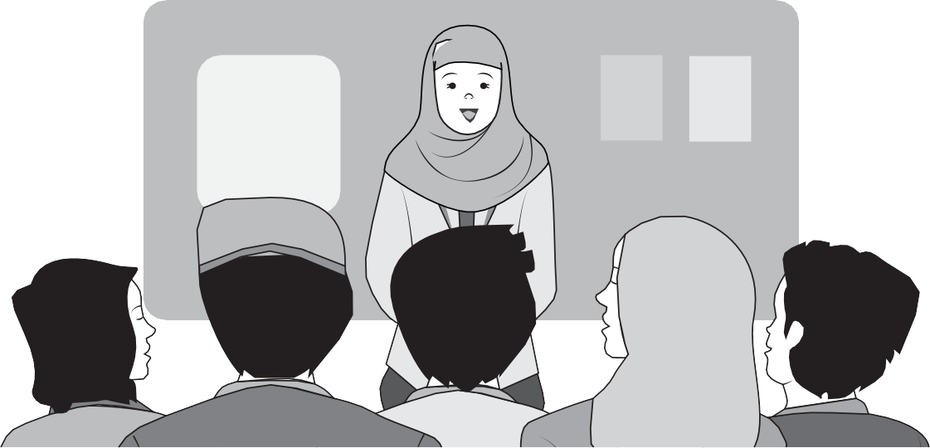

hen you are asked to speak in front of the class, your classmates will not just focus *on what you say*. They will also watch *how you*

W

*speak*, so be conscious not just of what you will say but also of how you are going to say it.

This second part of the module on speaking starts off with learning how to construct tag questions. You know how to construct tag questions, don’t you? There you have it. A tag question has just been constructed for you!

Along with tag question construction, the intonation patterns used for tag questions will also be discussed. After these concepts follows the construction of the parts of a speech—the introduction, body and conclusion.

Remember what was just said about your classmates watching you as you speak? This module will also provide you tips in gaining and projecting confidence in speaking and on becoming better listeners as well. In line with this, the appropriate verbal and non-verbal responses that must be observed by an audience when somebody is speaking are also discussed.

### MODULE 4

The last part of this module deals with the use of clear, vivid, and memorable language in writing speeches. After all, the kind of language a speaker uses is of key importance in driving his/her message across.



PRE-ASSESSMENT

Do you remember how people know the answer to a question, yet still ask it?

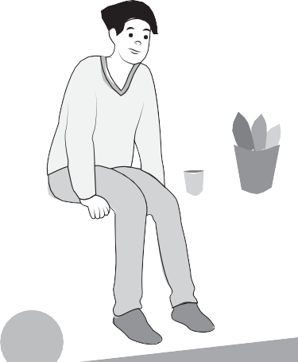

*You do remember, don’t you?*

Well, we just did it.

Tag questions are supplied to statements for the purpose of verifying or making sure of something.

“*She didn’t like to go, did she?*’’

—could be asked in two ways, depending on the intonation. The rising or the falling intonation can make a statement, or turn a statement into a genuine question.

SETTING THE PATH



# I AM READY, ARE YOU?

At the end of this lesson, you will be able to:

use intonation pattern in tag questions (LSICS/EN-S-PSB-JHS-78).



TRYING THIS OUT

**Directions:** Supply the statements with the appropriate tag questions. Write your answers on a separate sheet of paper.

1. She lives in Bulacan, ?
2. The sun is also a star, ?
3. Tomatoes are fruits, ?
4. You don’t love her anymore, ?
5. The rich businessman owns a ranch, ?
6. Orchids are aerial plants, ?
7. Tim and Ted did not attend the final rehearsal, ?
8. My uncle believes in reincarnation, ?
9. You don’t eat spicy foods, ?
10. Roel cannot make it to the conference tomorrow, ?

*She lives in Bulacan, doesn’t she? The sun is also a star, isn’t it? Tomatoes are fruits, aren’t they? You don’t love her anymore, do you? The rich businessman owns a ranch, doesn’t he?*

The secret in the construction of tag questions is that if the statement is positive **(She lives in Bulacan.)**, the tag question is negative **(doesn’t she?)**. If the statement is negative **(You don’t like it.)**, then the tag question is positive **(do you?)**

LESSON 1



## UNDERSTANDING WHAT YOU DID

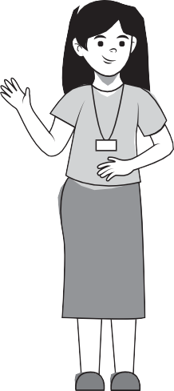

HELLO!

My name is Yasmin.

I am from Pasay City.

#### TAG QUESTIONS

*Tag questions* (or *question tags*) turn statements into questions. They are often used in verifying information that we think we know is true.

If the statement is **positive,** the question tag is **negative.**

If the statement is **negative,** the question tag is **positive.**

For example: It’s cold (positive), isn’t it (negative)?

It isn’t cold (negative), is it (positive)?

POSITIVE STATEMENTS WITH NEGATIVE TAG QUESTIONS

* She works as a research assistant, **doesn’t she?**
* They walk to school every day, **don’t they?**
* We will leave early tomorrow, **won’t we?**
* He’s already hungry, **isn’t he?**
* They are interested with the show, **aren’t they?**

NEGATIVE STATEMENTS WITH POSITIVE TAG QUESTIONS

* She doesn’t stay here anymore, **does she?**
* We aren’t aware of that, **are we?**
* They are not the ones we need, **are they?**
* We are not going in there, **are we?**
* You will not leave me alone, **will you?**

ACTIVITY

**Directions:** Supply the sentences with the appropriate tag questions. Write your answers on a separate sheet of paper.

1. He treats you well, ?
2. Lany is a thoughtful person, ?
3. The weather was cold last night, ?
4. Mark enjoys hiking with his friends, ?
5. She still lives here, ?
6. These art works are yours, ?
7. This dress looks nice on you, ?
8. Dancing is not Kelly’s cup of tea, ?
9. Like me, you’re also afraid of heights, ?
10. You won’t give up the fight, ?

### LESSON 1

###### Intonation in Tag Questions



The ***meaning*** of a tag question changes depending on the intonation pattern that you use. The *rising intonation* () will make a statement with question tag sound like a real question. The *falling intonation* (), on the other hand, will make it sound like a statement that does not require an answer.

They cannot attend, can they ()? They cannot attend, can they ()?

In these examples, the rising intonation on the tag indicates a genuine question. Here, the speaker isn’t sure if the information that he/she has is correct and requires a verification from the listener. On the other hand, the falling intonation on the question tag gives the impression that the information is correct.

ACTIVITY

1. Read the following with the rising intonation (↗):
   1. Your father is an artist, isn’t he? (↗)
   2. Melanie was at the party last night, wasn’t she? (↗)
   3. Reading science fiction is fun, isn’t it? (↗)
   4. Being engineering students, they all love math, don’t they? (↗)
   5. The boys put up the basketball ring themselves, didn’t

they? (↗)

1. Read the following with the falling intonation (↘):
   1. You don’t like oily foods, do you? (↘)
   2. Diane is not the type of person who would quit, is she? (↘)
   3. Mosquitoes do not live long, do they? (↘)
   4. Ben was not good at painting, was he? (↘)
   5. Cola drinks are not good for one’s health, are they? (↘)



**Understanding What You Did**

* **Tag questions,** or **question tags,** turn statements into
* questions.
* If the statement is **positive**, the question tag is **negative.**

•

If the statement is **negative**, the question tag is **positive.** The meaning of a question tag can be changed depending on the **intonation pattern used.**

## SHARPENING YOUR SKILLS

**Directions:** Supply each statement with the appropriate question tag. Write your answers on a separate sheet of paper.

1. It’s hot outside, ?
2. This house is unique, ?
3. These pots are made of recycled materials, ?
4. Animal dung makes a good fertilizer, ?
5. Complaining won’t change anything, ?
6. Jogging will exercise your entire body, ?
7. Many law violators do not realize their mistakes,

?

1. Tony holds a high position in the organization,

?

1. The minimum wage earners deserve a higher pay,

?

1. Obviously, I did not intend to offend anyone,

?



TREADING THE ROAD TO MASTERY

**Directions:** Answer the following guide questions. Write your answers on a sheet of paper.

1. What are tag questions?
2. When is a tag question negative?
3. When is a tag question positive?
4. What does it mean if you read a statement with a question tag using the rising intonation?
5. What does it mean to read a statement with a question tag using the falling intonation?

SETTING THE PATH



# LOOK IN THE EYE

At the end of this lesson, you will be able to:

use appropriate language when delivering speeches (LS1CS/EN-S-PSB-JHS-84);

deliver an informative speech using introduction, middle (body), and conclusion (LSICS/EN-S-PSB- JHS-81); and

identify techniques of public speaking (LSICS/EN- S-PSB-JHS-83).



TRYING THIS OUT

Write your answers on a separate sheet of paper.

1. Arrange the three parts of a speech in order.
   1. Conclusion
   2. Introduction
   3. Body
2. Write **T** if the statement is TRUE; write **F** if it is FALSE.
   1. Any speech should include an introduction, body, and conclusion.
   2. The purpose of the speech will help you identify the ideas that will support your main idea or message.
   3. Word choice is one consideration in writing a speech.
   4. Knowing the audience and the occasion is crucial in writing a speech.
   5. The approach that you will use in your introduction can determine the success of your speech.

The three parts of a written speech, in ***chronological order*** are the introduction, body, and the conclusion. Once you have written your speech and are ready to deliver it in front of your classmates, remember ***not*** to nervously look down at your feet. Stand straight, stay calm, and look at your audience in the eye. These are just some of the ways to effectively deliver a speech.

## UNDERSTANDING WHAT YOU DID



#### THE THREE BASIC PARTS OF A SPEECH



##### Introduction

The **introduction** should hook the interest of the listener. It might be a personal story, a quotation, a question, a trivia or statistics. An introduction also establishes the relevance of the speech. Tell your audience why the speech matters.

**The introduction needs to:**

🗸 capture the audience’s attention

🗸 present your main idea

🗸 preview what is to come

🗸 transition to the body

🗸 establish your credibility

##### Body



Conclusion

The **body** discusses the details of the main points of the speech. These main points you make in the body of the speech should be short and to the point.

The body...

🗸 outlines your main points

🗸 includes subpoints or supporting details that support your main points

🗸 includes transitions between main points

The **conclusion** restates your main points. It should also encourage the listener to think about the topic more deeply.



The conclusion...

🗸 signals that the end of the speech is coming

🗸 restates your main idea

🗸 ends strongly, but quickly

🗸 wraps up the points raised

🗸 drives your point home

##### SPEECH OUTLINE: Questions to Ask

**Introduction**

**·**

**·**

**·**

**·**

**·**

How will your opening be?

What will you say to get the audience’s attention? What is your speech all about?

Why should the audience listen to you? What will be the main points of your speech?

**Body**

**·**

**·**

**·**

**·**

**·**

What are the main points of your speech? What are the subpoints?

What are the supporting details? Will you give examples?

How do you transition from one subpoint to another?

**Conclusion**

**·**

**·**

**·**

**·**

How will you hint that your speech is about to end? What are your main points again?

What do you want your audience to remember? How do you want them to remember it?

ACTIVITY

* + 1. **Directions:** Which of the topics below do you find the most interesting? Pick one.
       1. Facebook kills face-to-face conversation skills.
       2. Texting is necessary for social survival.
       3. An online friend can be just as real and valuable as an offiine one.
       4. Is online media responsible for the breakdown of real- time relationships?
       5. Explain the value of social media to people who don’t use it.
       6. How can one avoid being cyber bullied?
       7. Explain the significance of responsible social media.
       8. Publicly “liking” or “not liking” a person’s posts can cause anxiety.
       9. Why do we avoid having a conversation with strangers?
       10. “Happy to Serve” is Miss Cruz’ goal in life.
    2. Create a body and a conclusion by answering two questions each from the *Speech Outline: Questions to Ask* given on page 15.

#### HOW TO DELIVER AN EFFECTIVE SPEECH

Effective, confident public speaking should look effortless. In reality, most people need considerable time and practice before they can talk confidently in front of an audience. You can use a number of techniques to overcome stage fright, to present yourself confidently, and to keep your audience engaged.

###### Avoid signs of nervousness

🗸 Think of yourself as someone who is sharing valuable information with willing listeners.

🗸 As long as you **appear calm**, it doesn’t really matter that you’re feeling nervous.

###### Develop good body language

🗸 **Smile.** This is the most important facial expression.

🗸 **Posture is crucial.** Stand up straight with your feet slightly apart and with your arms relaxed.

🗸 **Proper gestures.** Use your hands and arms to help your audience follow your speech. Effective, confident gestures command attention from listeners.

###### Make eye contact to engage people

🗸 Engage your audience by **making eye contact** with them.



🗸 Spend more time **looking at the audience** than your notes.

🗸 Look at your notes from time to time. Remember, however, not to read them for long periods of time while

delivering your speech.

Effective speech delivery will always be an important part of public speaking. No matter how inspiring, informative, or persuasive the speech you have written is, poor delivery will leave your audience feeling disappointed. Your presentation must be memorable as much as possible.

There are some people who seem to be natural-born public speakers. How lucky they are! For the rest of us, however, we may need a little coaching and some push to deliver our speeches more eloquently.



**Understanding What You Did**

* The three basic parts of a speech are **introduction,**
* A knowledge of basic public speaking techniques

**body,** and **conclusion.**

results in effective, confident public speaking.

## SHARPENING YOUR SKILLS

1. **Directions:** Guided by the questions below, draft a speech introducing yourself briefly.
2. What will you include in the introduction?
3. What will you include in the body?
4. What will you include in the conclusion?
5. **Directions:** Deliver the introduction that you drafted applying the tips below.

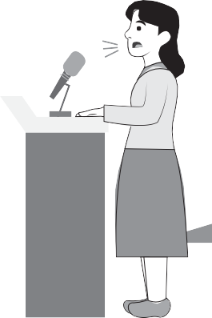

1. Practice making eye contact with your audience.
2. Try to relax your shoulders and keep your body open.
3. Try to raise your arms naturally as you speak.
4. Remind yourself to smile from time to time.



TREADING THE ROAD TO MASTERY

**Directions:** Write your answers on a separate sheet of paper.

* 1. Name the three basic parts of a speech.
  2. Briefly describe the contents of each part.
  3. Name at least three ways to deliver an effective speech.
  4. Explain briefly the ways to effective speech delivery.

SETTING THE PATH



# THE CLEARER IMAGE

At the end of this lesson, you will be able to:

use appropriate verbal and non-verbal cues when developing, maintaining, and ending conversations, dialogs, speeches, and interviews (LSICS/EN-S-PSB-JHS-79).



TRYING THIS OUT

**Directions:** Answer the following questions. Write your answers on a separate sheet of paper.

1. Which language creates a more interesting and clearer picture, abstract or concrete language? Why?
2. What is an abstract language?
3. What is a concrete language?
4. Which of the two makes use of specific descriptions or observations made through the use of any of the five senses?

**Abstract language** pertains to intangible concepts. These are concepts that are non-physical, such as love, honesty, education. Meanwhile, **concrete language** refers to those that are perceived by the senses and are, therefore, physical and tangible.

You have a box of chocolates or flowers to represent love, or a diploma to represent education. Obviously, the box of chocolates and diploma are the more precise, clearer images representing love and education. Their physicality involves the senses: touching and tasting the chocolates, reading the diploma and yes, hanging it by the wall.

## UNDERSTANDING WHAT YOU DID



#### THE USE OF CLEAR LANGUAGE

Language can be our most powerful tool. We use it to understand our world through listening and reading. We use it to communicate our own feelings, needs, and desires through speaking and writing. With strong language skills, we have a much better chance of understanding and being understood. We use it to get what we want and need from those around us.

Vivid language—life-like and realistic language—helps listeners create strong, distinct, clear, and memorable mental images. Good vivid language usage helps an audience truly understand and imagine what a speaker is saying.

When we use language that is **concrete,** we attempt to help our audiences see specific realities or actual instances instead of purely **abstract** thoughts and ideas.

##### Abstract and General Language

**Abstract language** includes words that express thoughts and ideas, such as *bravery, freedom, love,* and *compassion.*

Thoughts and ideas are intangible (something you cannot touch), but they are essential to any type of sentence formation. Without thoughts and ideas, anything said will lack basis and foundation. General language requires clarification. Specific details must be given to support what is being said.

##### Concrete and Specific Language

**Concrete and specific language**, by contrast, includes words that can be touched, seen, heard, felt, or even smelled. They are anything our senses can detect; they are tangible. They help to create clear images in the mind of the listener.

Consider the following situations.

***Situation 1:***



Compare...

The *long snake* ate the *big pig.*

With

The *20-foot, adult reticulated python* swallowed the *60-pound wild boar* whole.

Compare...

I will show you *things* from long ago.

With

I will show you a *large box* containing *old, broken toys* from my childhood.

“Long snake” and “big pig” are *concrete words*. They are tangible. They can be perceived by the senses. They can be touched or seen. However, they are *general terms.* We can still turn them into specifics, with details, to make them more interesting. “20-foot, adult reticulated python” and “60-pound wild boar” are more attention catching than simply “long snake” and “big pig.”

***Situation 2:***



Compare...

I didn’t like the coffee.

With

The bitter coffee was not hot, tasted too bitter, and looked like dirty water.

Compare...

The man’s face was unforgettable.

With

The man had a scar across his face, a huge wart on the nose, and his teeth were missing.

Here the terms “didn’t like” and “unforgettable” are *general terms.* We specify why we didn’t like the coffee: It “was not hot, tasted too bitter, and looked like dirty water.” We give details on why the man’s face was unforgettable: He “had a scar across the face, a huge wart on the nose, and his teeth were missing.”

Can you see the differences? Using concrete, specific language drives the main idea home more directly. Using indefinite, general, abstract, or unclear and imprecise language not only leaves listeners confused; their minds might begin to wander to other matters.

ACTIVITY

**Directions:** Identify which of the concepts below is Abstract **(A)**

or Concrete **(C)**. Write your answers on a separate sheet of paper.

1. glass
2. house
3. deception
4. love
5. leaf
6. book
7. banana
8. loyalty
9. education
10. high school diploma

#### HOW TO BE AN EFFECTIVE LISTENER

Remember the following verbal and non-verbal response cues when listening to speeches:

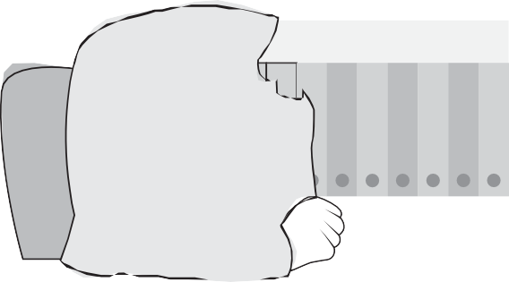

🗸 Make **eye contact** while the other person speaks. Lean toward the other person and nod your head occasionally.

🗸 Instead of offering unsolicited advice or opinions, simply **restate** what has been said. You might start this off by saying “Oh, you mean…’’

🗸 **Do not interrupt** while the other person is speaking. Do not prepare your reply while the other person speaks.

🗸 In addition to listening to what is said, **watch nonverbal behavior** such as facial expressions, tone of voice, and other behaviors to pick up on the hidden meaning.

🗸 **Avoid daydreaming.** While listening, avoid thinking of other things.

🗸 Show interest by asking questions to clarify what is said. To encourage the speaker, ask open-ended questions such as “Why do you think she said that?”

🗸 **Avoid abruptly changing the subject.** This will appear that you were not listening to the other person in the first place.

🗸 As you listen, be open, neutral, and **withhold judgment**.

###### TRY ACTIVE LISTENING

The way to improve your listening skills is to practice **active listening.** This is when you make a conscious effort to hear not only the words that another person is saying. More importantly, you pay attention to the **complete message** being communicated. In order to do this, you must pay attention to the other person very carefully.

You cannot allow yourself to become distracted by whatever else may be going on around you. You cannot form counter arguments while the other person is still speaking. Nor can you allow yourself to get bored. You might lose focus on what the other person is saying.

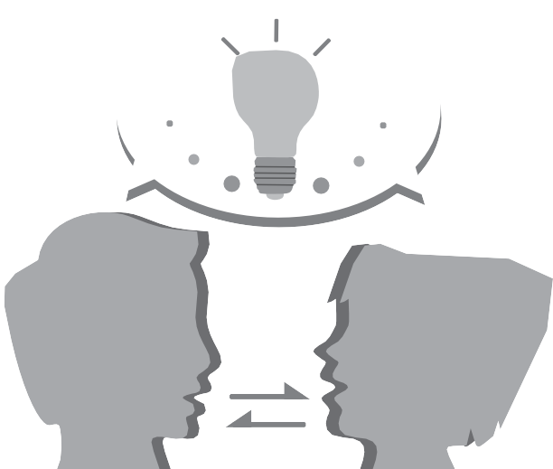

***TIP!***

* If you’re finding it particularly difficult to concentrate

on what someone is saying, try mentally repeating the words being said. This will reinforce the message and help you to stay focused.

* To enhance your listening skills, you need to let the

other person know that you are listening to what he/ she is saying. Remember, pay attention to the complete message.



**Understanding What You Did**

* Good clear language usage helps audience truly

•

understand and imagine what a speaker is saying. There are appropriate verbal and nonverbal response cues when listening to speeches.

## SHARPENING YOUR SKILLS

Write your answers on a separate sheet of paper.

* 1. Transform the following sentences into something more concrete and specific.
     1. He is quite tall.
     2. She is annoying.
     3. The movie was nice.
     4. Their home is far.
     5. The food is good.
  2. List at least two specific and concrete details to make each of the following abstract words meaningful and tangible.

***Example:*** democratic - election, voting

* + 1. success - .
    2. freedom - .
    3. beautiful - .
    4. happiness - .
    5. love - .



TREADING THE ROAD TO MASTERY

**Directions:** Answer the questions below on a separate sheet of paper.

1. What is the difference between abstract and concrete language?
2. Why is concrete language more appropriate when delivering a speech?
3. Name three appropriate response cues when listening to a speech.
4. How can you be an effective listener? Give five (5) nonverbal responses.



DON’T FORGET

* + Tag questions turn statements into questions. They are often used for checking information that we think we know is true. If the statement is **positive,** the

“

question tag is **negative.** If the statement is **negative,**

the question tag is **positive.**

* + The three basic parts of a speech are the **introduction, body,** and **conclusion.** When we use a language that is concrete when delivering a speech, we attempt

to help our audiences see specific realities or actual instances, instead of purely abstract thoughts and ideas.

* + When listening to speeches you should practice **active listening.** This is when you make a conscious effort to listen not only to the words that another person

is saying but you pay attention to the **complete message** being communicated.

## EXPLORE MORE

**Concrete Language**. Concrete language is better than abstract language. However, there are times when our communication demands the use of abstract language. How do you know when it is better to use abstract language than concrete language at a given time?

REACH THE TOP



**Talk to somebody.** Now apply these appropriate nonverbal response cues: Make eye contact as the person speaks. Do not interrupt, and as you listen, be open and neutral by withholding judgement on what the speaker is saying. Was it easy to do? Was it a challenge? Perhaps, it largely depends on who you’re talking to.

LESSON 1: I AM READY, ARE YOU?

TRYING THIS OUT

1. She lives in Bulacan, **doesn’t she?**
2. The sun is also a star, **isn’t it?**
3. Tomatoes are fruits, **aren’t they?**
4. You don’t love her anymore, **do you?**
5. The rich businessman owns a ranch, **doesn’t he?**
6. Orchids are aerial plants, **aren’t they?**
7. Tim and Ted did not attend the final rehearsal, **did they?**
8. My uncle believes in reincarnation, **doesn’t he?**
9. You don’t eat spicy foods, **do you?**
10. Roel cannot make it to the conference tomorrow, **can he?**

UNDERSTANDING WHAT YOU DID

ACTIVITY I

1. He treats you well, doesn’t he?
2. Lany is a thoughtful person, isn’t she?
3. The weather was cold last night, wasn’t it?
4. Mark enjoys hiking with his friends, doesn’t he?
5. She still wants me though, doesn’t she?
6. These art works are yours, aren’t they?
7. This dress looks nice on you, doesn’t it?
8. Dancing is not Kelly’s cup of tea, is it?
9. Like me, you’re also afraid of heights, aren’t you?
10. You won’t give up the fight, will you?

ACTIVITY II – A

1. Your father is an artist, isn’t he? (↗)
2. Melanie was at the party last night, wasn’t she? (↗)
3. Reading science fiction is fun, isn’t it? (↗)
4. Being engineering students, they all love math, don’t they? (↗)
5. The boys put up the basketball ring themselves, didn’t they? (↗)

PAGE 5

PAGE 7

PAGE 9

ACTIVITY II – B

1. You don’t like oily foods, do you? (↘)
2. Diane is not the type of person who would quit, is she? (↘)
3. Mosquitoes do not live long, do they? (↘)
4. Ben was not good at painting, was he? (↘)
5. Cola drinks are not good for one’s health, are they? (↘)

SHARPENING YOUR SKILLS

ACTIVITY I

1. It’s hot outside, isn’t it?
2. This house is unique, isn’t it?
3. These pots are made of recycled materials, aren’t they?
4. Animal dung makes a good fertilizer, doesn’t it?
5. Complaining won’t change anything, will it?
6. Jogging exercises your entire body, doesn’t it?
7. Many law violators do not realize their mistakes, do they?
8. Tony holds a high position in the organization, doesn’t he?
9. The minimum wage earners deserve a higher pay, don’t they?
10. Obviously, I did not intend to offend anyone, did I?

TREADING THE ROAD TO MASTERY

PAGE 10

PAGE 11

1. Tag questions (or question tags) turn statements into questions.
2. If the statement is positive, the question tag is negative.
3. If the statement is negative, the question tag is positive.
4. The rising intonation (↗), will make the statement with a tag question sound like a real question.
5. With falling intonation (↘), will make the statement with a tag question sound like a question that doesn’t require a real answer.

LESSON 2: LOOK IN THE EYE

TRYING THIS OUT

PAGE 13

ACTIVITY I

* 1. Introduction
  2. Body
  3. Conclusion

ACTIVITY II

**1.** T

**2.** T

**3.** T

**4.** T

**5.** T

TREADING THE ROAD TO MASTERY

1. Name the three basic parts of a paragraph.

**·**

Introduction Body Conclusion

**·**

**·**

1. Briefly describe each part of a speech.

**·**

The **introduction** should hook the interest of the listeners. The **body** of a speech discusses in detail its main points. The **conclusion** restates your main points.

**·**

**·**

1. Name the three ways to deliver an effective speech. Briefly discuss each.

**·**

Avoid signs of nervousness. As long as you appear calm, it doesn’t really matter that you’re feeling nervous.

**·**

Develop good body language. Effective, confident gestures command attention from listeners.

**·**

Make eye contact to engage people.

PAGE 21

LESSON 3: THE CLEARER IMAGE

TRYING THIS OUT

1. Concrete language uses specific realities or actual instances.
2. Abstract language makes use of intangible concepts.
3. Concrete language makes use of tangible concepts.
4. Concrete language because it employs tangible concepts. Tangible concepts are those that the senses can detect.

UNDERSTANDING WHAT YOU DID

ACTIVITY

PAGE 23

PAGE 27

**1.** C

**2.** C

**3.** A

**4.** A

**5.** C

**6.** C

**7.** C

**8.** A

**9.** A

10. C

SHARPENING YOUR SKILLS

ACTIVITY I

1. He stands six feet and two inches tall.
2. She keeps on interrupting me when I’m on the phone.
3. The movie shows the values of honesty and loyalty.
4. Their home is 45 kilometers away from school.
5. The food uses only the freshest ingredients.

ACTIVITY II

1. graduation, job, winner
2. summer vacation, self-employment, divorce
3. lady, dress, scenery
4. chocolates, video games, gifts
5. family, friends, couple

PAGE 31

TREADING THE ROAD TO MASTERY

* 1. Abstract language uses intangible concepts; concrete language uses tangible ones.
  2. Concrete language can create clear images in the mind of the listeners.
  3. (1) Make eye contact while the other person speaks.
     1. Do not interrupt while the other person is speaking.
     2. Avoid daydreaming.

PAGE 32

## GLOSSARY

Abstract Language

Active Listening

Body

Conclusion

Concrete Language

Effective Speech Delivery

Introduction

Tag Question

**Abstract language** includes words that express thoughts and ideas; they are intangible concepts

—something that literally ’cannot be touched,’ or sensed.

**Active listening** is the act of making a conscious effort to not only listen to the words that another person is saying, but more importantly, paying attention to the entire message being communicated.

The part of a written speech that discusses the details of the main points of a speech.

The part of a written speech that restates the main points and encourages the listener to think about the topic more deeply.

**Concrete and specific language** includes words that can be detected by the senses; they can be touched, seen, heard, felt, or even smelled.

**Effective speech delivery** pertains to the way a speech is presented and delivered to keep the audience engaged.

Introduction is the part of a written speech that establishes its relevance; it tells the audience why the speech being delivered matters.

**Tag questions**, or **question tags**, are added at the end of statements, turning the statements into questions.

## REFERENCES

Baraceros, Esther L., Ph.D. *Improving Students’ Study Skills and Reading or Thinking Strategies.* Manila: Rex Book Store, Inc. 2014.

The development and printing of this learning resource was made possible with the cooperation of Asia Paciflc College. This is a component of the project “Better Life for Out-of-School Girls to Fight Against Poverty and Injustice in the Philippines” implemented by UNESCO Office, Jakarta in partnership with the Department of Education. This initiative received a generous flnancial support from Korea International Cooperation Agency (KOICA).

For inquiries, please contact:

Department of Education, Bureau of Learning Resources (DepEd BLR)

Office Address : Ground Floor, Bonifacio Building, DepEd Complex,

Meralco Avenue, Pasig City, Philippines 1600

Telefax : +63-2-8631-1072; +63-2-8634-1054; +63-2-8631-4985

Email Address : blr.qad@deped.gov.ph; [blr.lrpd@deped.gov.ph](mailto:blr.lrpd@deped.gov.ph)